**HEURISTIC EVALUATION**

EXPERT 1

|  |  |
| --- | --- |
| TASKS | Problems faced |
| Find the chapter named ”The Interaction Cycle and the User Action Framework”. | Did not have the patience to scroll through the list of contents. So I typed the whole chapter name in search and found the page as the first result.  Rating:  Frequency: 4  Impact: 3  Persistence: 2  Heuristic violated: **Flexibility and efficiency of use.**  On being asked to find a chapter towards the end of the book, most novice users would scroll through the contents list. |
| Identify the number of headings on page 108. | No problems faced as such. But the text colour on the headings make it very difficult to read.  Rating:  Frequency: 5  Impact: 2  Persistence: 3 |
| Find the definition of “ethnography”. | Fairly straightforward. However, the dictionary tab could have had an icon of a book or a bigger tab.  Rating:  Frequency: 4  Impact: 2  Persistence: 1  **Heuristic violated: Match between system and the real world.** |
| Find the third occurrence of the word “Experience”. | The word a user searches for needs to be highlighted on clicking the search results. Most new ebook readers have this feature.  Rating:  Frequency: 5  Impact: 3  Persistence: 3  **Heuristic violated: Visibility of system status.** |
| Go to page 69 and download the page in the form of PDF. | The tab “download” changes to “please wait” on clicking once and cannot be clicked again. If a user saves the file once and would like to save it again to another location he/she would not be able to do so unless they click on another tab and come back to the download tab.  Rating:  Frequency: 5  Impact: 4  Persistence: 4  **Heuristic violated: User control and freedom** |
| Copy the first paragraph on page 2 into a notepad and save it on the desktop. | A novice user would try to copy the text directly till he/she spots the copy button and realizes it. Also, the copy option only allows the user to copy the page they’re on. It would not work if the user wishes to copy a paragraph spread across two pages.  Rating:  Frequency: 4  Impact: 4  Persistence: 4  **Heuristic violated: User control and freedom** |
| Find the publication year of the ebook. | A novice user would look for words like “Info” or “Book info” than the word the ebook reader has (details).  Rating:  Frequency: 4  Impact: 3  Persistence: 3  **Heuristic violated: Match between system and the real world.** |
| Find the FAQ (Frequently Asked Questions) and provide a feedback for the ebook reader. | Would prefer a tab at the top with the words FAQ. |
| Go to page number 93 and make a note titled with your name. | On going to the Notes tab, the user should ideally be presented with a note that can be edited directly instead of asking users to click on “Create new” and then loading a screen with an editable note.  Rating:  Frequency: 4  Impact: 2  Persistence: 2  **Heuristic violated: Match between system and the real world.** |
| Go to page number 93 and make a note with the content “Hello usability” and download it in endnote format. | On going to the Notes tab, the user should ideally be presented with a note that can be edited directly instead of asking users to click on “Create new” and then loading a screen with an editable note.  Rating:  Frequency: 4  Impact: 2  Persistence: 2  **Heuristic violated: Match between system and the real world.** |

Screenshots:

Task 1:

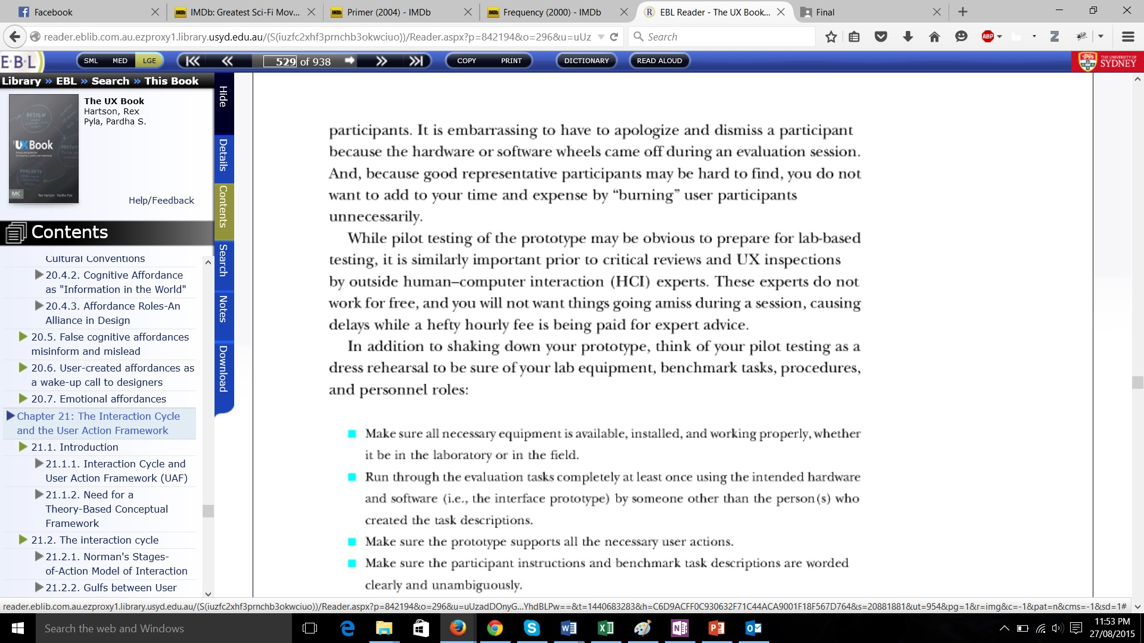

Task 2:

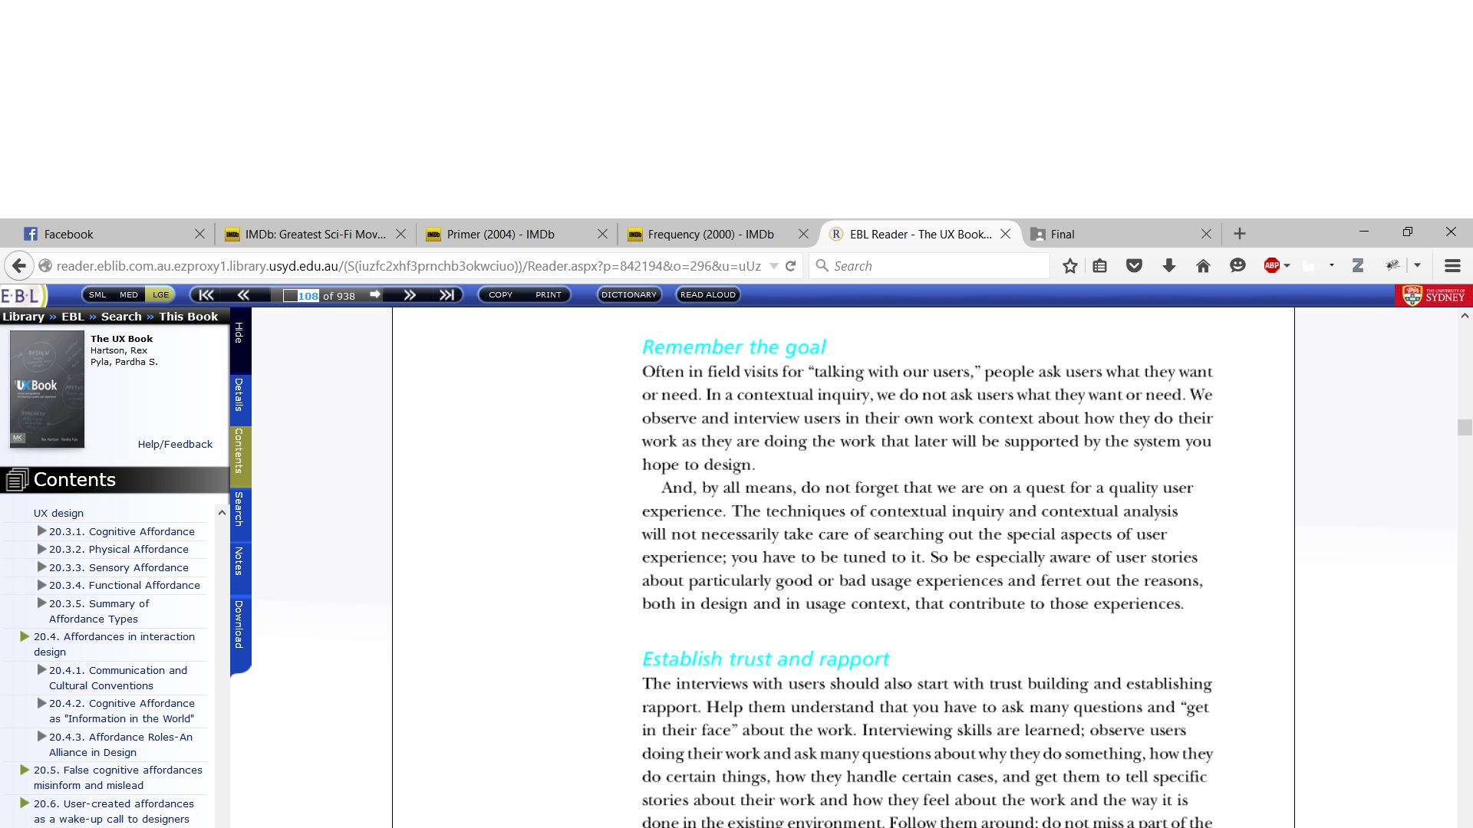

Task 3:

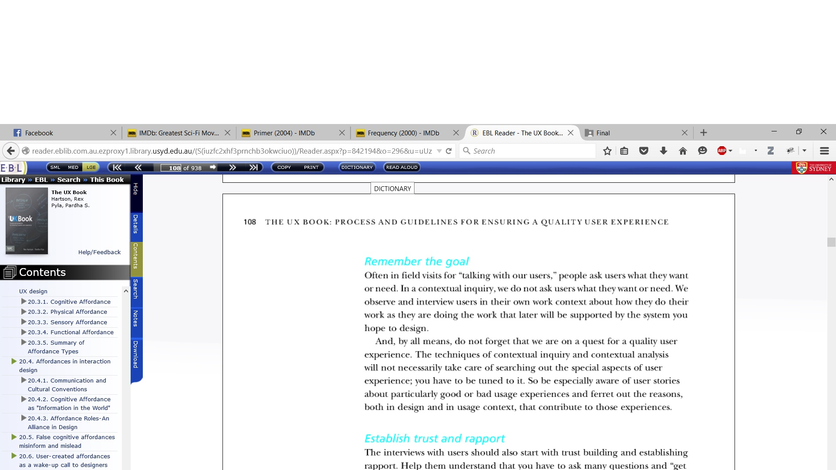

Task 4:

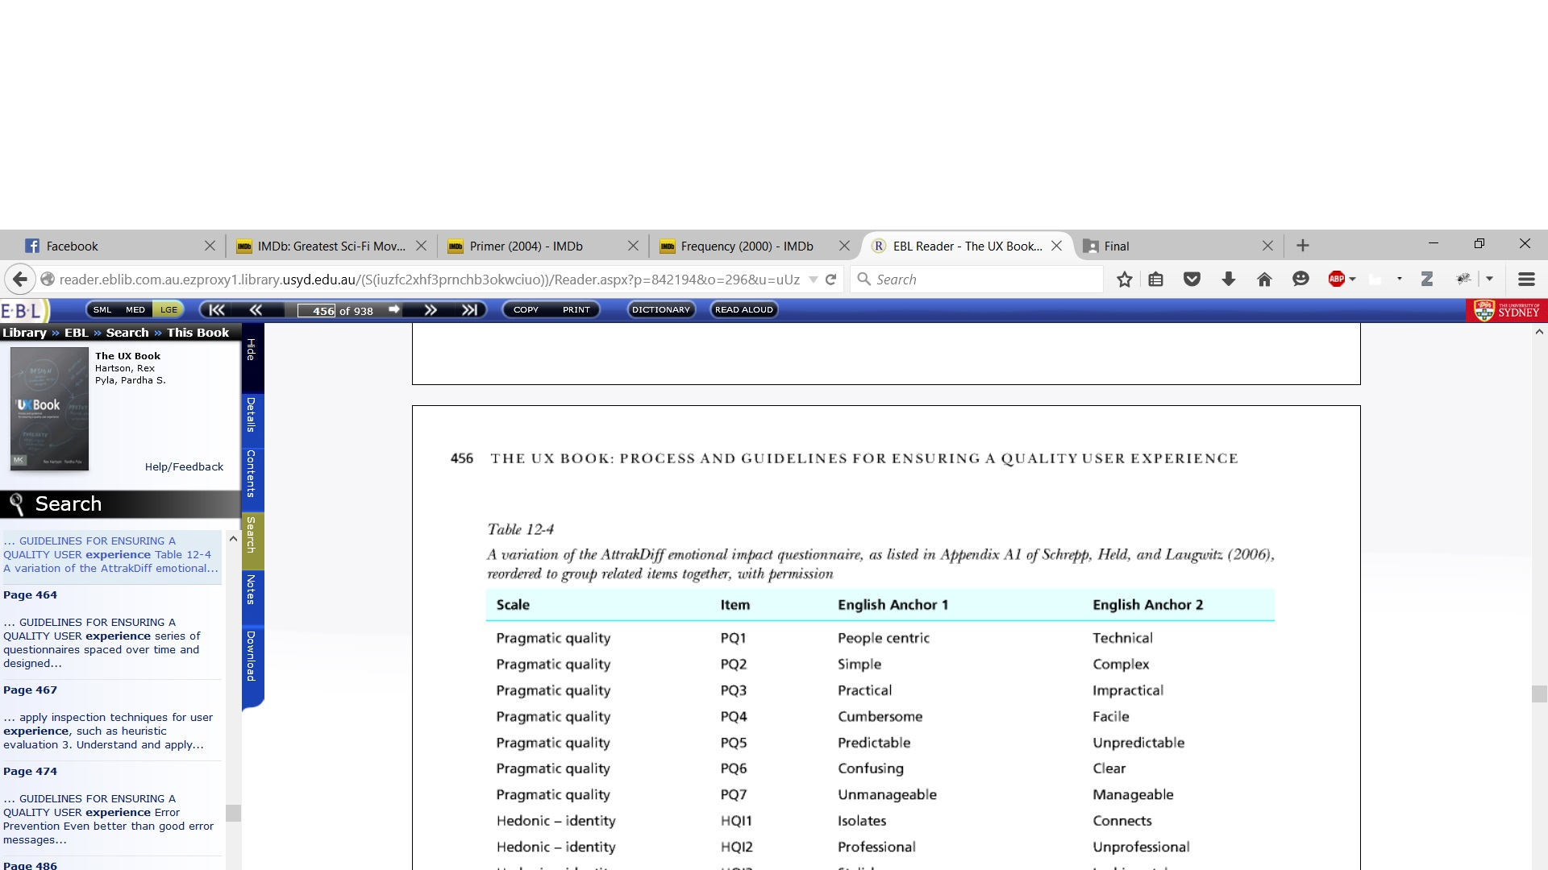

Task 5:

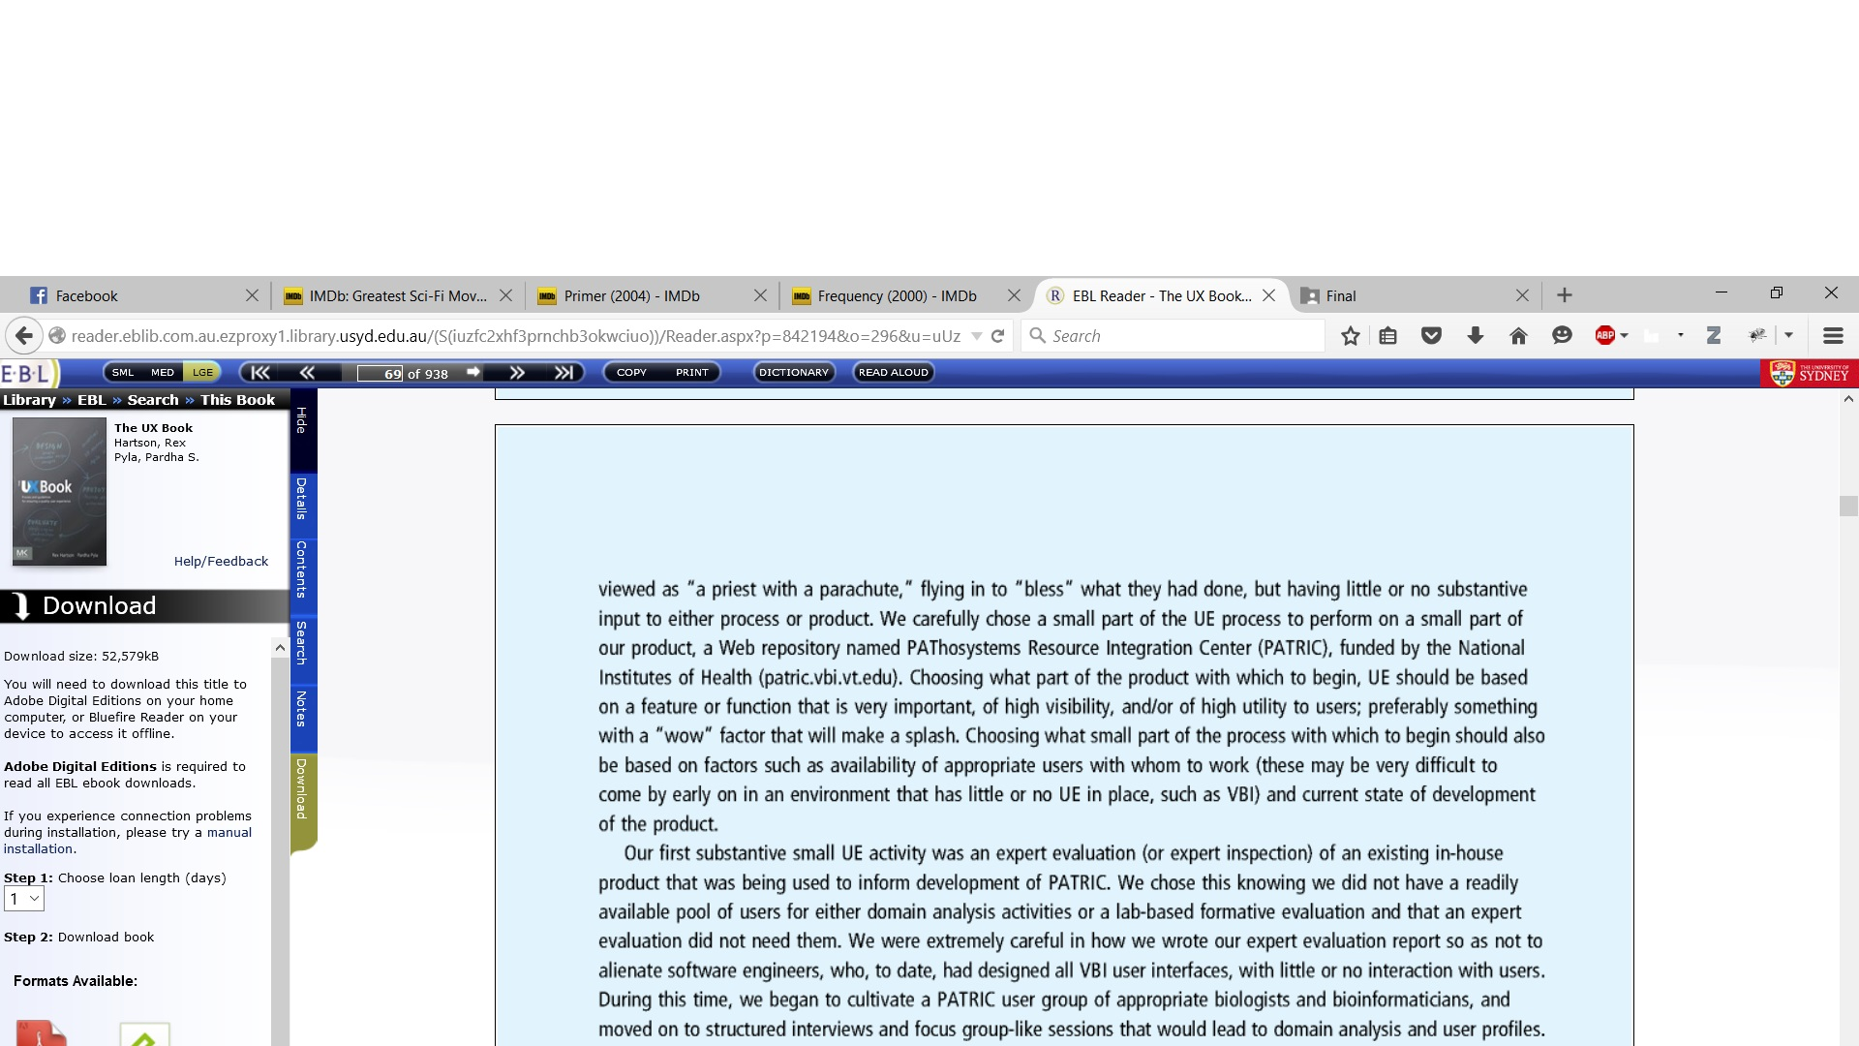

Task 7:

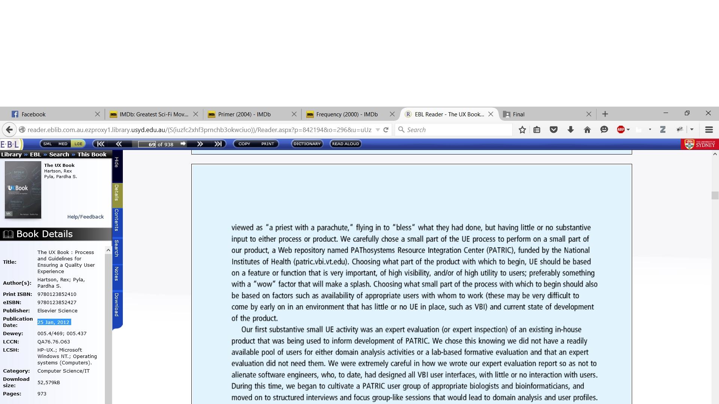

Task 8:

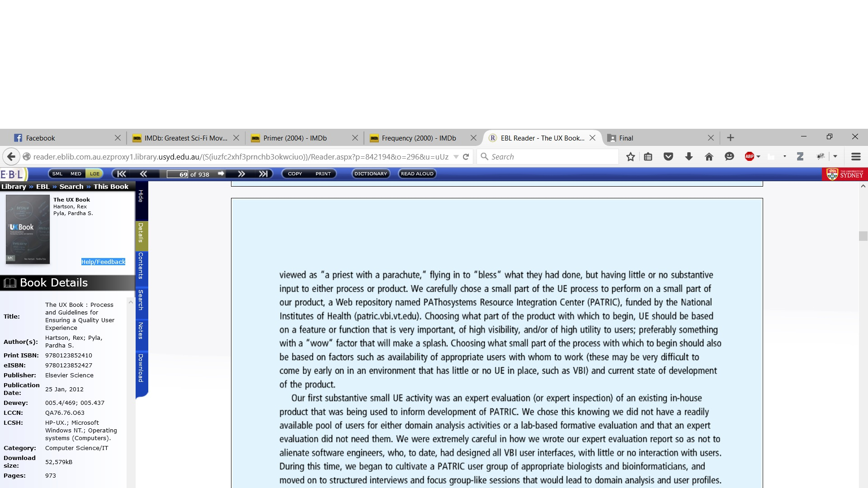

Task 9:

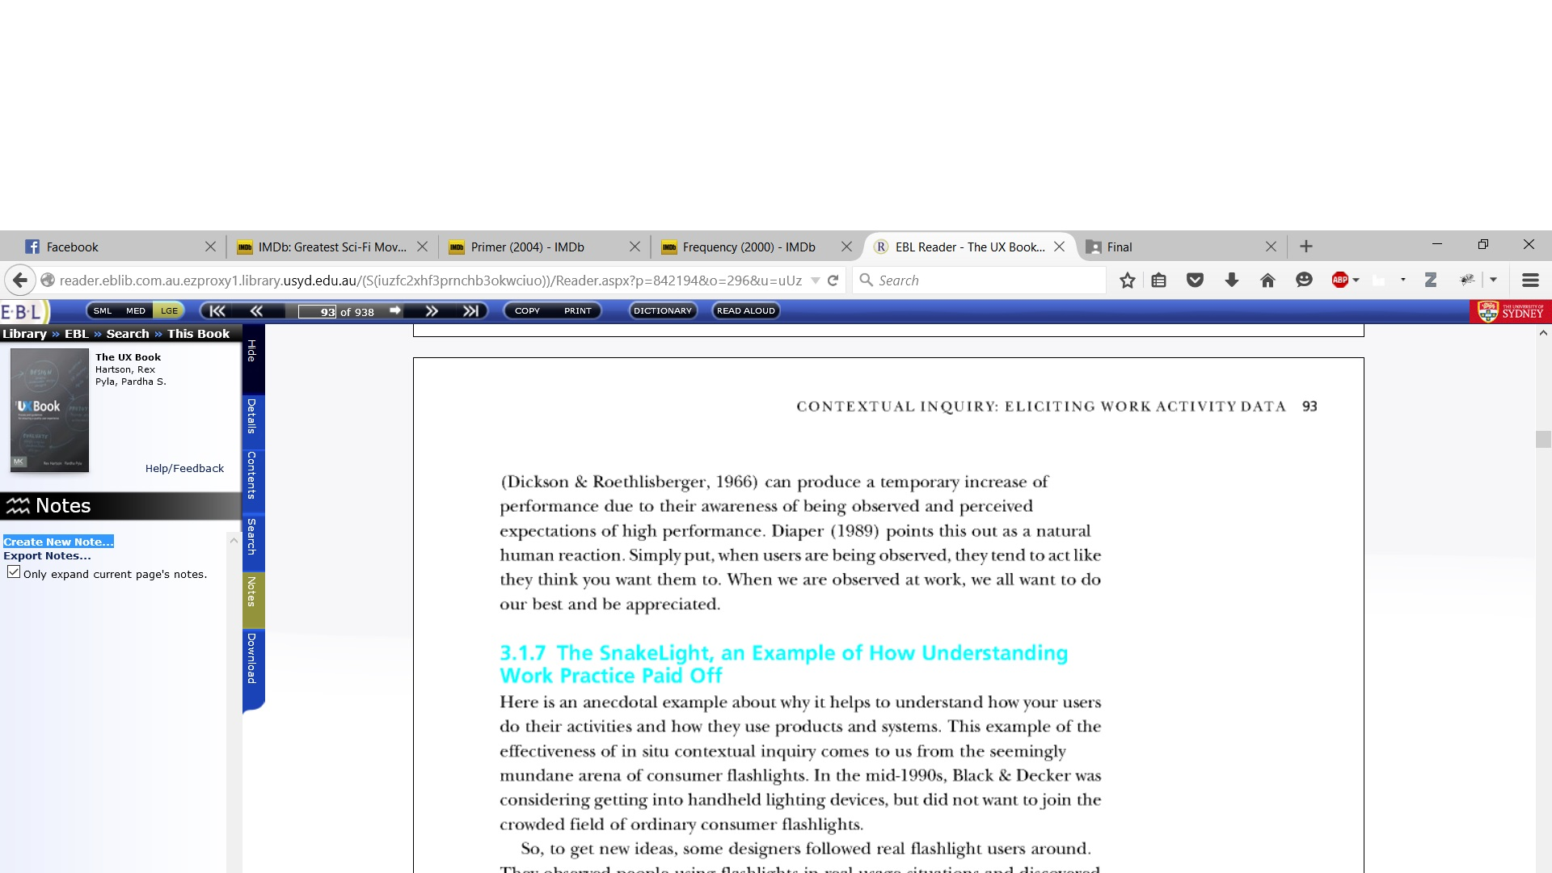

Comparison with Nielsen’s Heuristics:

1. Visibility of system status:
2. Match between system and real world:
3. User control and freedom:
4. Consistency and standards:
5. Error prevention:
6. Recognition rather than recall:
7. Flexibility and efficiency of use:
8. Aesthetic and minimalist design:
9. Help users recognize, diagnose, recover from errors:
10. Help and documentation: